

Lab # 04
Information Security
Instructor: Annyat ullah

Student Name: | Muhammad Abdullah
Registration No: | FA24-BSE-042
Department: | Software Engineering
Submission Date: 17 March 2026

COMSATS University Islamabad

Activity 1: Entering keys manually

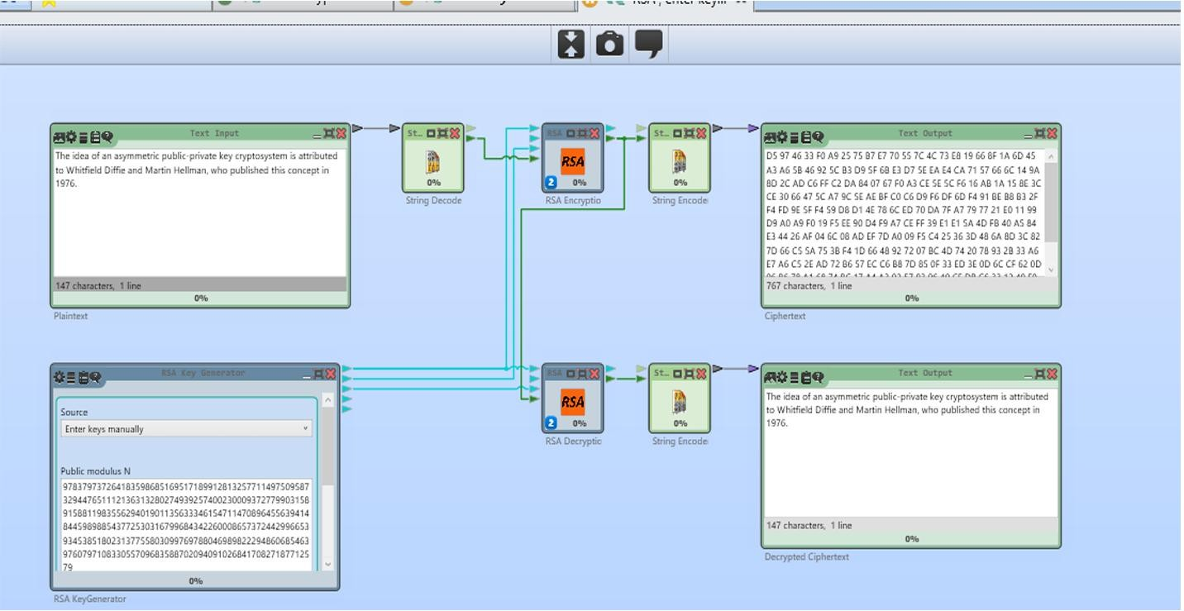

Activity 2: Enter primes manually

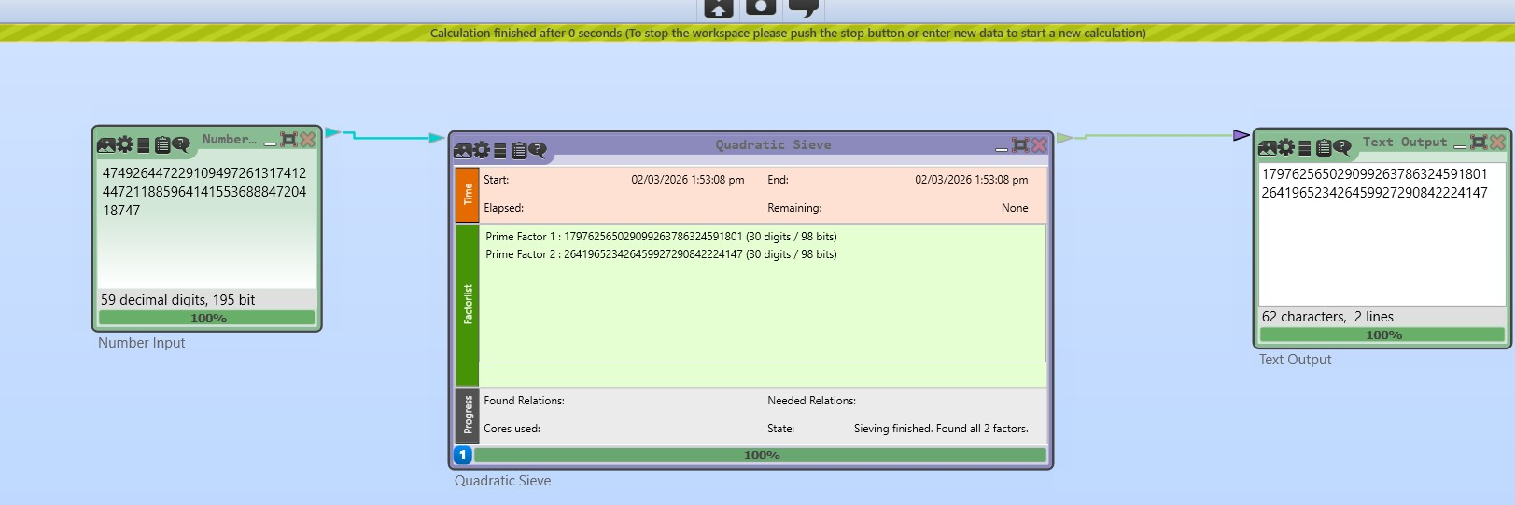

Activity 3: RSA common factor attack

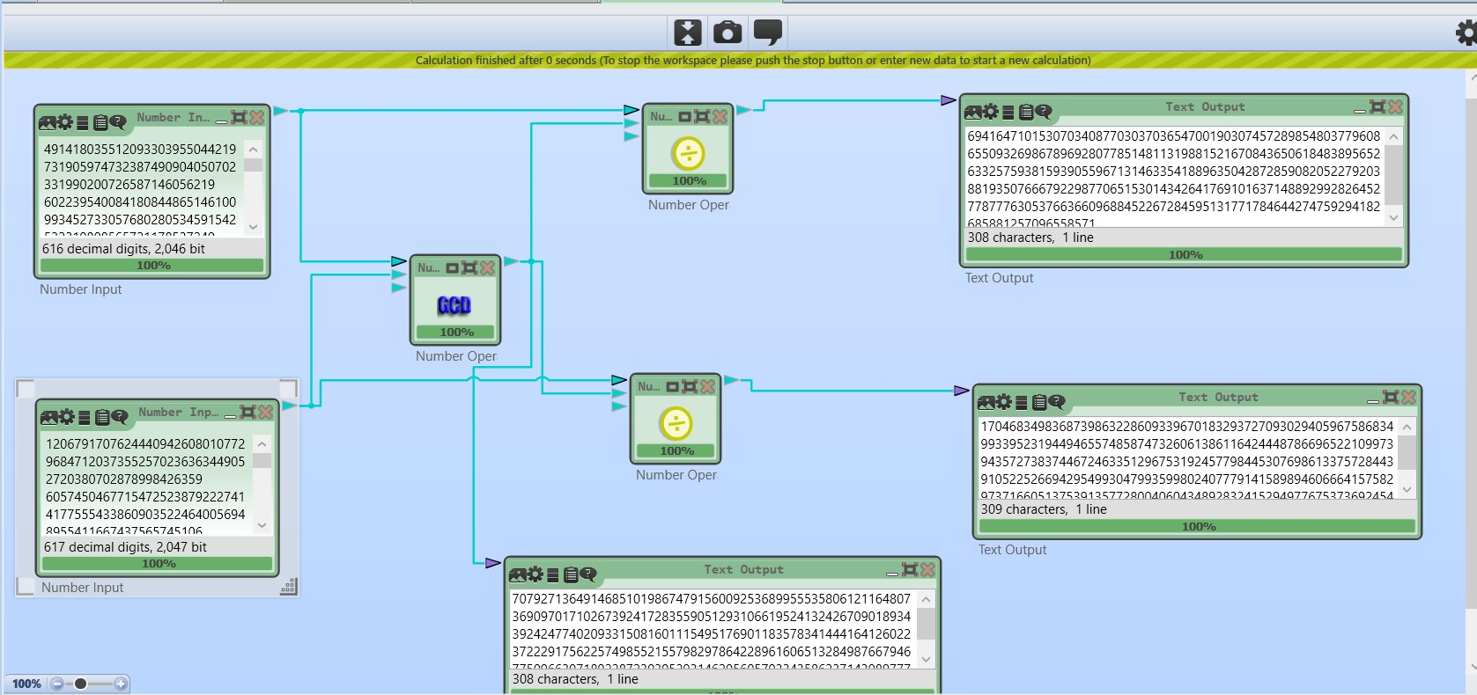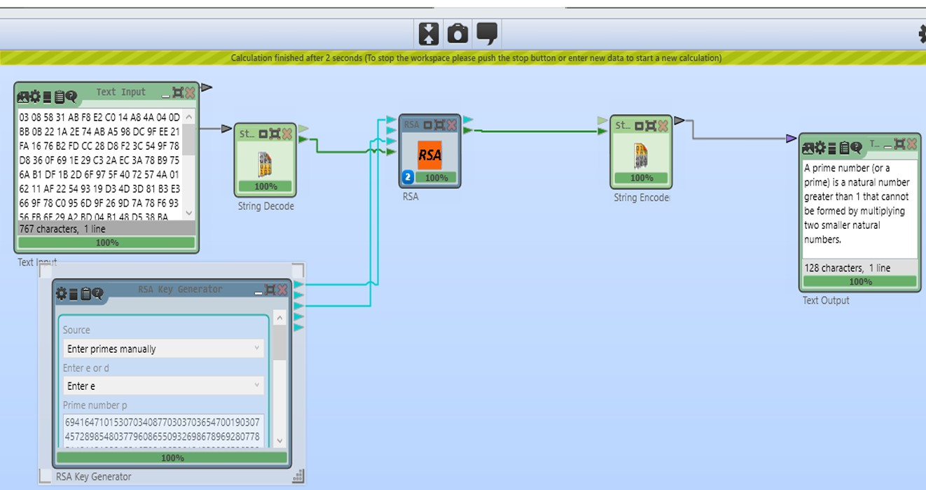

LABTASK 1:
I found evercrack tool everywhere but did not finded it and there was not any ECC components in the Cryptool 2. LABTASK 2 AND 3:
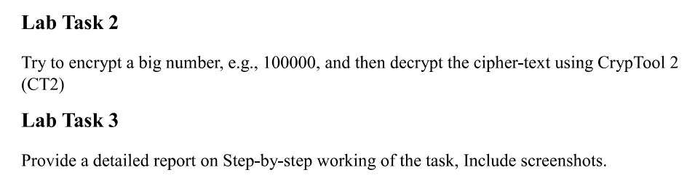

Similar as Activity 1:


Encryption and Decryption with a Big Number:
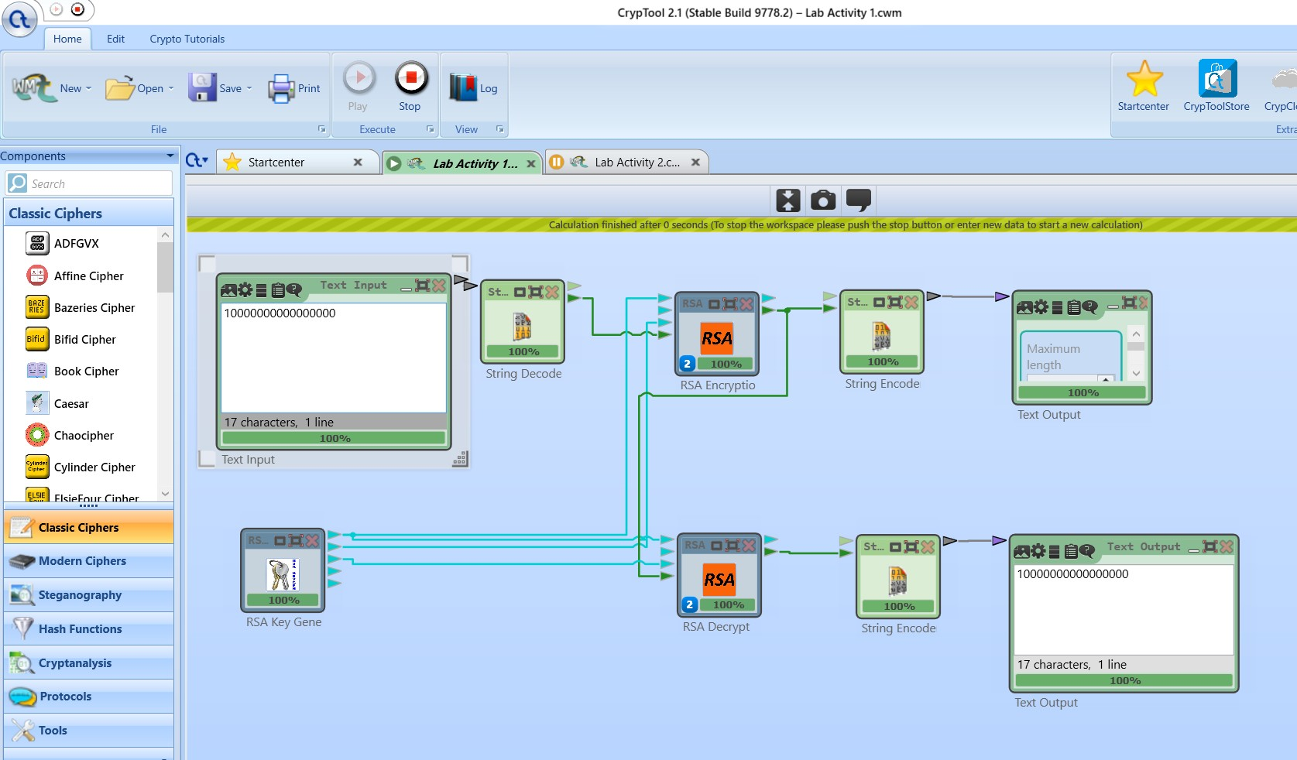

LABTASK 3:

1. Key Generation: The Mathematical Foundation
Before any data is processed, the RSA Key Generator must create the necessary cryptographic keys. Unlike symmetric encryption (like AES) which uses one key, RSA uses a mathematically linked pair:
- Public Key (e, n): This is used for Encryption. It can be shared with anyone.
- Private Key (d, n): This is used for Decryption. It must be kept secret.
- Process: The generator picks two large prime numbers (p and q) to calculate the modulus (n = p \times q) and the exponents (e and d).

2. Input and Decoding: Preparing the Data
The Text Input component holds the numeric value you wish to protect.
- Data Type: While it looks like a "number" to us, computers treat it as a string of characters.
- Decoding: The Decoder component converts this human-readable text into a raw byte stream or a large integer format that the RSA mathematical engine can “calculate”.

3. RSA Encryption: Locking the Data
The decoded numeric value (let's call it m) is passed into the RSA Encryption component along with the Public Key.
- The Calculation: The component performs a modular exponentiation:
C = m^e \pmod{n}
- Result: The output is the Ciphertext (C). This is a completely different, seemingly random numeric value that hides the original input.

4. RSA Decryption: Unlocking the Data
The Ciphertext is then routed to the RSA Decryption component. This component requires the Private Key generated in the first step.
- The Calculation: Using the secret exponent $d$, the component "reverses" the math: m = C^d \pmod{n}
- Security: Only the holder of the Private Key can perform this calculation to retrieve the original value.

5. Final Output and Verification
The decrypted data is passed to an output display (like a Text Display or Visualizer).
• Success Criteria: Because the final output matches the original input, it confirms Integrity (the data didn't change) and Authenticity (the keys worked as a pair).

Lab Task 4:
I found CryptTool 2 most effective and easy to use due to Its easy User interface and non-complexity. EverCrack Software wasn’t available so hence I was not able to use it
Lab Task 5:
One issue faced during the lab was that the EverCrack software was not available, so the ECC task could not be performed. Another minor difficulty was understanding and correctly connecting the components in CrypTool 2 at first.

